Project Design Phase
Solution Architecture

Date | [DD Month YYYY]
Team ID | [Team ID]
Project Name | Automated Network Request Management in ServiceNow
Maximum Marks | 4 Marks

Solution Architecture:
Solution architecture is a complex process – with many sub-processes – that bridges the gap between business problems and technology solutions. Its goals are to:
- Find the best tech solution to solve existing business problems.
- Describe the structure, characteristics, behavior, and other aspects of the software to project stakeholders.
- Define features, development phases, and solution requirements.
- Provide specifications according to which the solution is defined, managed, and delivered.

Solution Architecture Diagram:
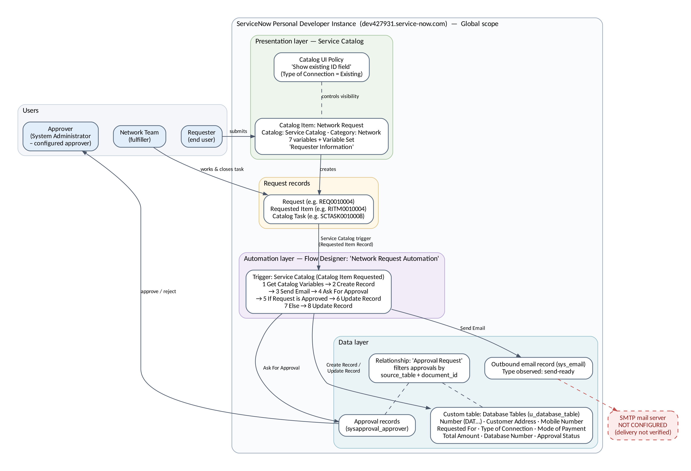
Figure 1: Solution architecture of Automated Network Request Management in ServiceNow
Layers and components
• Presentation: the Network Request catalog item (Service Catalog, category Network, short description 'Network Services Request') with seven variables and the 'Requester Information' variable set. The Catalog UI Policy 'Show existing ID field' shows 'Enter your existing id' only when Type of Connection = Existing.
• Request records: submission creates the standard request records (e.g. REQ0010004 / RITM0010004). A catalog task (e.g. SCTASK0010008, linked to RITM0010004) is worked and closed by the Network Team.
• Automation: the Flow Designer flow 'Network Request Automation' (Global scope, Active) uses a Service Catalog trigger, so it starts when the Network Request item is requested. It gets the catalog variables, creates a Database Tables record, sends the email, asks for approval and updates the record in the then (approved) or Else branch.
• Data: the custom table Database Tables (u_database_table); approval records; the 'Approval Request' relationship, which filters approvals by source_table and the parent's sys_id (document_id); and the outbound email record.
• External: an SMTP mail server is required to deliver email. It is not configured, so the email record stays send-ready and delivery is not verified.
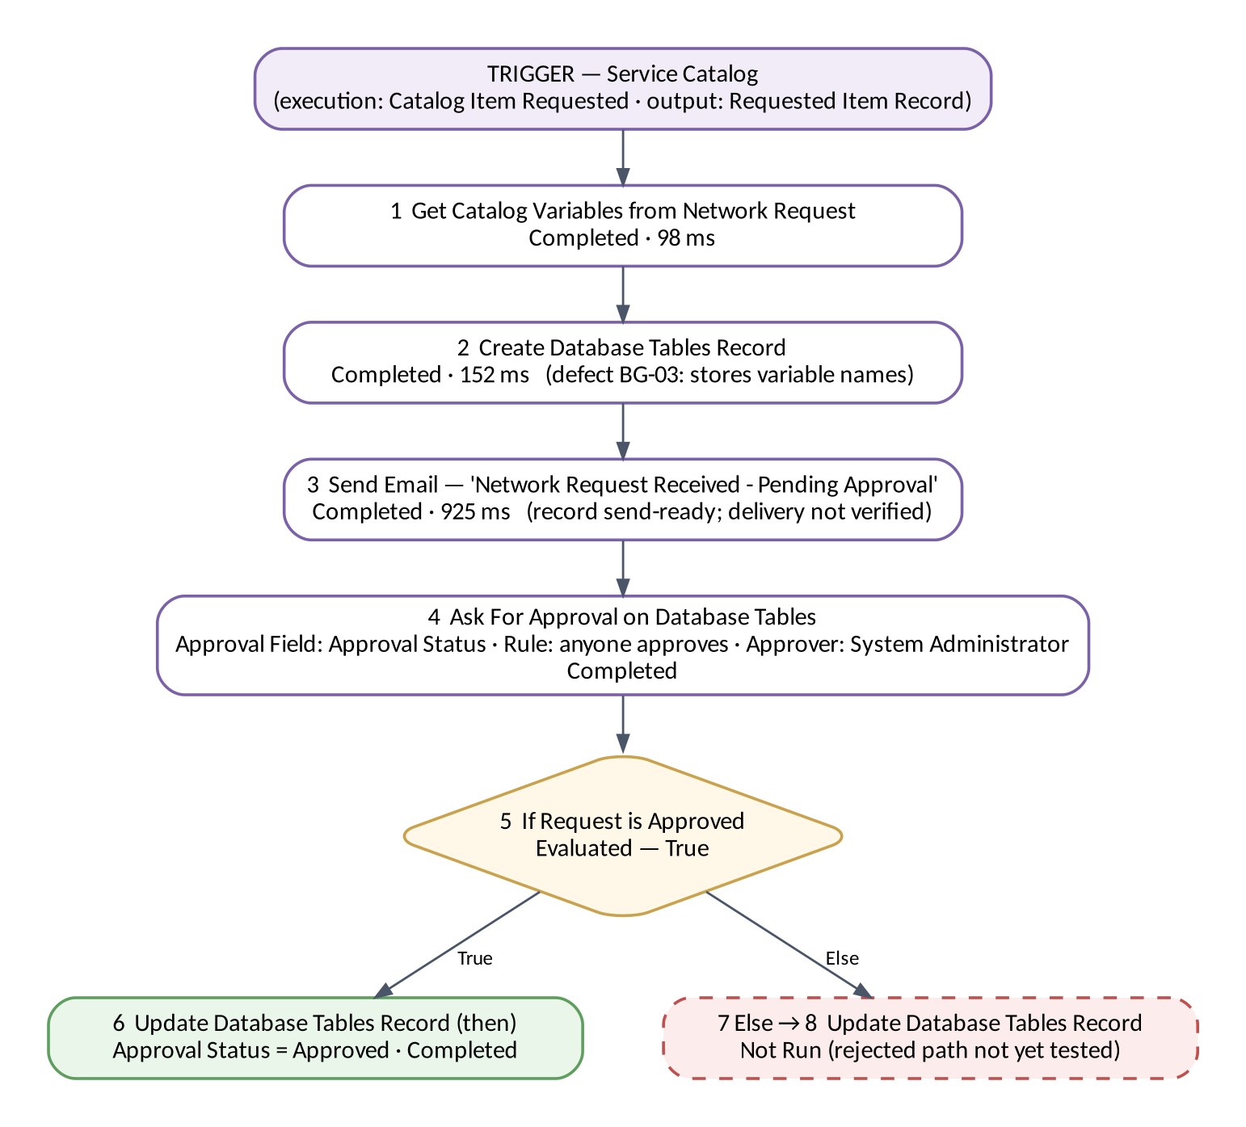
Figure 2: Flow Designer execution flow — Network Request Automation
Figure 3: Request lifecycle (example references from testing)
Note: the example references (REQ0010004, RITM0010004, SCTASK0010008, DAT0001016) come from different test activities on 2026-10-19, not from one single execution.

